190905104
lab 4

1)
#include <mpi.h>
#include <stdio.h>
#include <string.h>
#define BUFSIZE 100
void Error_Handler(int error_code);
int main(int argc, char *argv[])
{
int size, rank;
int sum = 0;
int fact = 1;
MPI_Init(&argc, &argv);
MPI_Errhandler_set(MPI_COMM_WORLD, MPI_ERRORS_RETURN);
int error_code;
error_code = MPI_Comm_size(MPI_COMM_WORLD, &size);
error_code = MPI_Comm_rank(MPI_COMM_WORLD, &rank);
Error_Handler(error_code);
int sendval = rank + 1;
MPI_Scan(&sendval, &fact, 1, MPI_INT, MPI_PROD, MPI_COMM_WORLD);
fprintf(stdout, "process[%d]: fact is %d\n", rank, fact);
fflush(stdout);
MPI_Scan(&fact, &sum, 1, MPI_INT, MPI_SUM, MPI_COMM_WORLD);
if (rank == size - 1)
printf("Answer is: %d\n", sum);
return 0;
}
void Error_Handler(int error_code)
{
if (error_code != MPI_SUCCESS)
{
char error_string[BUFSIZE];
int length_of_error_string, error_class;
MPI_Error_class(error_code, &error_class);
MPI_Error_string(error_code, error_string, &length_of_error_string);
printf("%d %s\n", error_class, error_string);
}
}

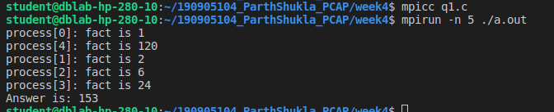

2)
#include <mpi.h>
#include <stdio.h>
#include <string.h>
int main(int argc, char *argv[])
{
int rank, size;
int i = 0, j;
int k = 0, fac = 1, ans[1000], sum = 0;
int n, a[100][100], b[100];
float x, y, area, pi1;
MPI_Init(&argc, &argv);
MPI_Comm_rank(MPI_COMM_WORLD, &rank);
// Set the error handler to MPI_ERRORS_RETURN
MPI_Errhandler_set(MPI_COMM_WORLD, MPI_ERRORS_RETURN);
MPI_Comm_size(MPI_COMM_WORLD, &size);
int error = MPI_Bcast(&size, 1, MPI_INT, 0, MPI_COMM_WORLD);
if (error != MPI_SUCCESS)
{
char s[100];
int len, class1;
MPI_Error_string(error, s, &len);
MPI_Error_class(error, &class1);
fprintf(stderr, "Error description is %s", s);
fflush(stderr);
fprintf(stderr, "Error class is %d", class1);
fflush(stderr);
}
x = (float)(rank + 1) / size;
y = 4.f / (1 + x * x);
area = (1 / (float)size) * y;
MPI_Reduce(&area, &pi1, 1, MPI_FLOAT, MPI_SUM, 0, MPI_COMM_WORLD);
if (rank == 0)
{
fprintf(stdout, "%f\n", pi1);
fflush(stdout);
}
MPI_Finalize();
return 0;
}
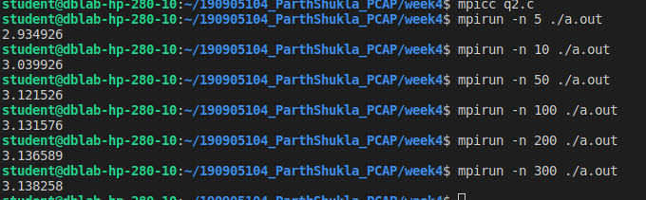

3)
#include <stdio.h>
#include <mpi.h>
void ErrorHandler(int error_code)
{
char error_string[MPI_MAX_ERROR_STRING];
int length_of_error_string, error_class;
MPI_Error_class(error_code, &error_class);
MPI_Error_string(error_code, error_string, &length_of_error_string);
if (error_code != 0)
printf("error class %d \n error string %s\n", error_class, error_string);
}
void main(int a, char *b[])
{
int rank, ele, size;
int a1[3][3];
int b1[3];
int count = 0;
int tc = 0;
int error_code;
MPI_Init(&a, &b);
MPI_Comm_rank(MPI_COMM_WORLD, &rank);
MPI_Comm_size(MPI_COMM_WORLD, &size);
MPI_Errhandler_set(MPI_COMM_WORLD, MPI_ERRORS_RETURN);
error_code = MPI_Comm_size(MPI_COMM_WORLD, &size);
ErrorHandler(error_code);
if (rank == 0)
{
printf("Enter elements into matrix\n");
for (int i = 0; i < 3; i++)
{
for (int j = 0; j < 3; j++)
{
scanf("%d", &a1[i][j]);
}
}
printf("Enter element to count \n");
scanf("%d", &ele);
}
MPI_Bcast(&ele, 1, MPI_INT, 0, MPI_COMM_WORLD);
MPI_Scatter(a1, 3, MPI_INT, b1, 3, MPI_INT, 0, MPI_COMM_WORLD);
for (int i = 0; i < 3; i++)
{
printf("%d ", b1[i]);
if (b1[i] == ele)
{
count++;
}
}
printf("\nProcess %d found %d occurrences\n", rank, count);
MPI_Reduce(&count, &tc, 1, MPI_INT, MPI_SUM, 0, MPI_COMM_WORLD);
if (rank == 0)
{
printf("\nNumber of occurrences is %d\n", tc);
}
MPI_Finalize();
}

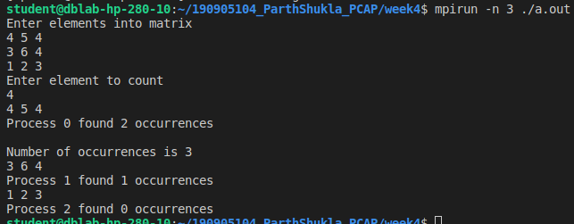

4)

#include <mpi.h>
#include <stdio.h>
#include <string.h>
void ErrorHandler(int error_code)
{
if (error_code != MPI_SUCCESS)
{
char error_string[BUFSIZ];
int length_of_error_string, error_class;
MPI_Error_class(error_code, &error_class);
MPI_Error_string(error_code, error_string, &length_of_error_string);
printf("%d %s\n", error_class, error_string);
}
}
int main(int argc, char *argv[])
{
int rank, size, error_code;
int i = 0, j;
int k = 0, fac = 1, ans[1000], sum = 0;
int n, a[100][100], b[100];
MPI_Init(&argc, &argv);
error_code = MPI_Comm_rank(MPI_COMM_WORLD, &rank);
error_code = MPI_Comm_size(MPI_COMM_WORLD, &size);
if (rank == 0)
{
printf("Enter the elements of i/p matrix \n");
for (i = 0; i < 4; i++)
{
for (j = 0; j < 4; j++)
{
scanf("%d", &a[i][j]);
}
}
printf("\n");
}
error_code = MPI_Scatter(a, 100, MPI_INT, b, 100, MPI_INT, 0, MPI_COMM_WORLD);
error_code = MPI_Scan(b, ans, 4, MPI_INT, MPI_SUM, MPI_COMM_WORLD);
ErrorHandler(error_code);
for (i = 0; i < 4; i++)
{
printf("%d ", ans[i]);
}
printf("\n");
MPI_Finalize();
return 0;
}

